## FPT- APTECH International School

## ---o0o---

## **PROJECT REPORT**

## 

## **Drink World**

## 

## **Instructor: Mr. Nguyen Tuan**

## **Class: T2108A1**

## **Semester: 2**

## **Group: 1**

## 

## · **StudentTH2108064 Dao Quang Linh**

## · **StudentTH2108054 Nguyen Du Quynh Nga**

## · **StudentTH2108041 Le Xuan Bac**

## · **Student1332621 Doan Quang Manh**

## · **StudentTH2107026 Ho Anh Dung**

**Table of Contents**

1. Problem Definition 3

1.1 Overview 3

i. Introduction 3

Ii. Implementation Environment 3

1.2 User Stories 4

Customer 4

[i. Log in](https://docs.google.com/document/d/1l6fd-97iTlC3_cDi1oBR0YUnp7yWUTYw/edit#heading=h.3dy6vkm) 4

[ii . Register](https://docs.google.com/document/d/1l6fd-97iTlC3_cDi1oBR0YUnp7yWUTYw/edit#heading=h.1t3h5sf) 4

[Iii. Search by name](https://docs.google.com/document/d/1l6fd-97iTlC3_cDi1oBR0YUnp7yWUTYw/edit#heading=h.4d34og8) 4

[Iv. View the description of each product](https://docs.google.com/document/d/1l6fd-97iTlC3_cDi1oBR0YUnp7yWUTYw/edit#heading=h.2s8eyo1) 4

2. Follow chart 5

2.1 GUI 1: register 5

[2.2 GUI 2: login](https://docs.google.com/document/d/1l6fd-97iTlC3_cDi1oBR0YUnp7yWUTYw/edit#heading=h.26in1rg) 6

[2.3 GUI 3: cart](https://docs.google.com/document/d/1l6fd-97iTlC3_cDi1oBR0YUnp7yWUTYw/edit#heading=h.lnxbz9) 7

[2.4 GUI 4:](https://docs.google.com/document/d/1l6fd-97iTlC3_cDi1oBR0YUnp7yWUTYw/edit#heading=h.35nkun2) term 8

[2.5 GUI 5:](https://docs.google.com/document/d/1l6fd-97iTlC3_cDi1oBR0YUnp7yWUTYw/edit#heading=h.35nkun2) add product 9

[2.6 GUI 6:](https://docs.google.com/document/d/1l6fd-97iTlC3_cDi1oBR0YUnp7yWUTYw/edit#heading=h.35nkun2) map 10

[2.7 GUI 7:](https://docs.google.com/document/d/1l6fd-97iTlC3_cDi1oBR0YUnp7yWUTYw/edit#heading=h.35nkun2) search by name 11

[2.8 GUI 8:](https://docs.google.com/document/d/1l6fd-97iTlC3_cDi1oBR0YUnp7yWUTYw/edit#heading=h.35nkun2) product detail 12

[3. UI\UX](https://docs.google.com/document/d/1l6fd-97iTlC3_cDi1oBR0YUnp7yWUTYw/edit#heading=h.1ksv4uv) 15

[3.1 Homepage](https://docs.google.com/document/d/1l6fd-97iTlC3_cDi1oBR0YUnp7yWUTYw/edit#heading=h.44sinio) 15

[3.2 About us](https://docs.google.com/document/d/1l6fd-97iTlC3_cDi1oBR0YUnp7yWUTYw/edit#heading=h.2jxsxqh) 16

[3.3 Login](https://docs.google.com/document/d/1l6fd-97iTlC3_cDi1oBR0YUnp7yWUTYw/edit#heading=h.z337ya) 17

[3.4 Signup](https://docs.google.com/document/d/1l6fd-97iTlC3_cDi1oBR0YUnp7yWUTYw/edit#heading=h.3j2qqm3) 18

[3.5 Products](https://docs.google.com/document/d/1l6fd-97iTlC3_cDi1oBR0YUnp7yWUTYw/edit#heading=h.1y810tw) 19

[3.6 Cart](https://docs.google.com/document/d/1l6fd-97iTlC3_cDi1oBR0YUnp7yWUTYw/edit#heading=h.4i7ojhp) 20

[3.7](https://docs.google.com/document/d/1l6fd-97iTlC3_cDi1oBR0YUnp7yWUTYw/edit#heading=h.2xcytpi) 21

[3.8](https://docs.google.com/document/d/1l6fd-97iTlC3_cDi1oBR0YUnp7yWUTYw/edit#heading=h.1ci93xb) 22

[3.9 add product](https://docs.google.com/document/d/1l6fd-97iTlC3_cDi1oBR0YUnp7yWUTYw/edit#heading=h.3whwml4) 23,24

[3.10 product detail](https://docs.google.com/document/d/1l6fd-97iTlC3_cDi1oBR0YUnp7yWUTYw/edit#heading=h.2bn6wsx) 25

[4. Summary](https://docs.google.com/document/d/1l6fd-97iTlC3_cDi1oBR0YUnp7yWUTYw/edit#heading=h.1pxezwc) 28

# 

# **Problem Definition**

## **Overview**

### Introduction

**Requirement Specification:**

The Web site is to be created based on the following requirements.

1. Trang chủ phải chứa thông tin về nước uống(trà sữa) và hình ảnh phù hợp
2. Trang web hiển thị một menu chứa các tùy chọn ngắn gọn giới thiệu về các loại nước uống(trà sữa)
3. Trang web có chứa chức năng order

### Implementation Environment

* Platform
* Windows 10
* Công nghệ sử dụng
* WebStorm
* Github
* Intellij

Frontend :

* HTML 5
* CSS
* Javascript
* JQuery
* Bootstrap
* Angular
* Java thymeleaf

Backend : javaScript+Spring Boot, mysql.

## **User Stories**

# **Follow chart**

## **GUI 1: Register**

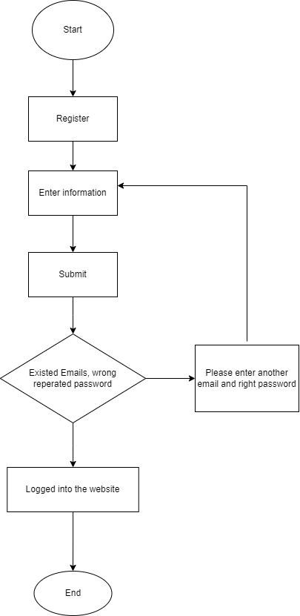

2.2 **GUI 2: Login**

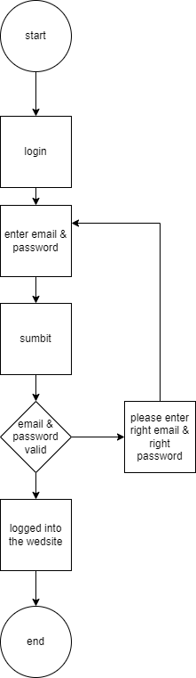

2.3 **GUI 3: Cart**

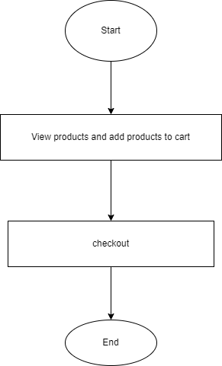

2.4 **GUI 4: Term**

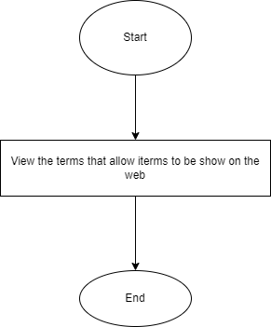

2.5 **GUI 5: add product**

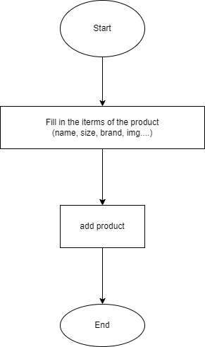

2.6 **GUI 6: Map**

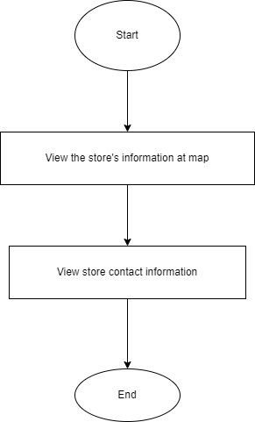

2.7 **GUI 7: Search by name**

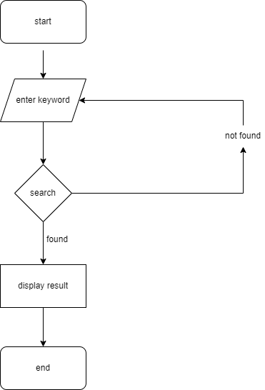

2.8 **GUI 8: Product detail**

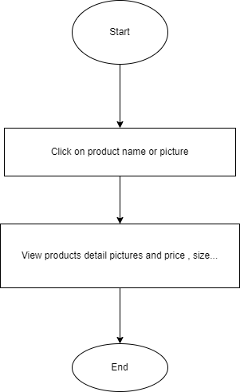

**3.UI/UX**

**3.1 Homepage**

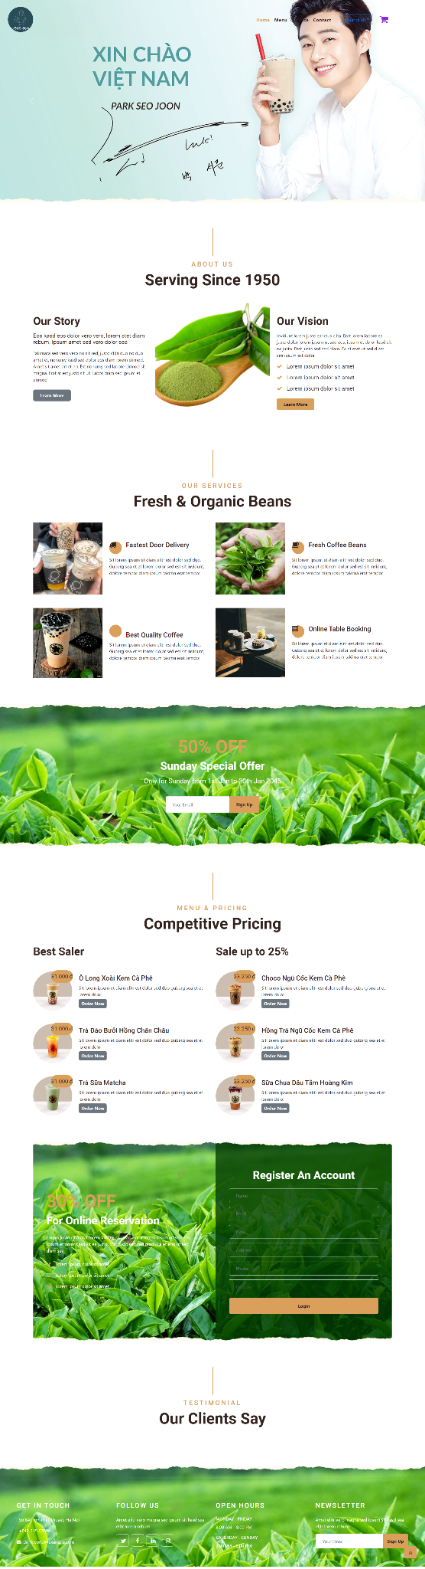

**3.2 Service**

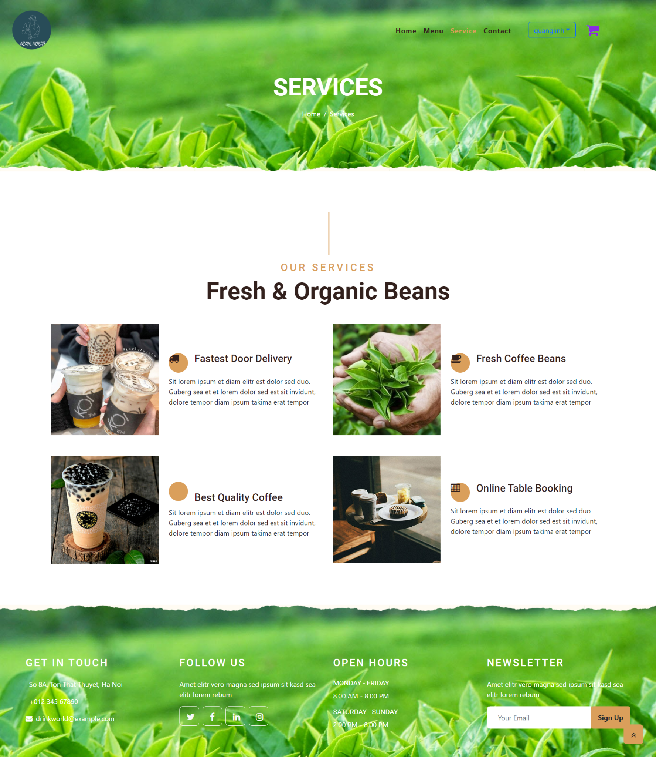

**3.3 Login**

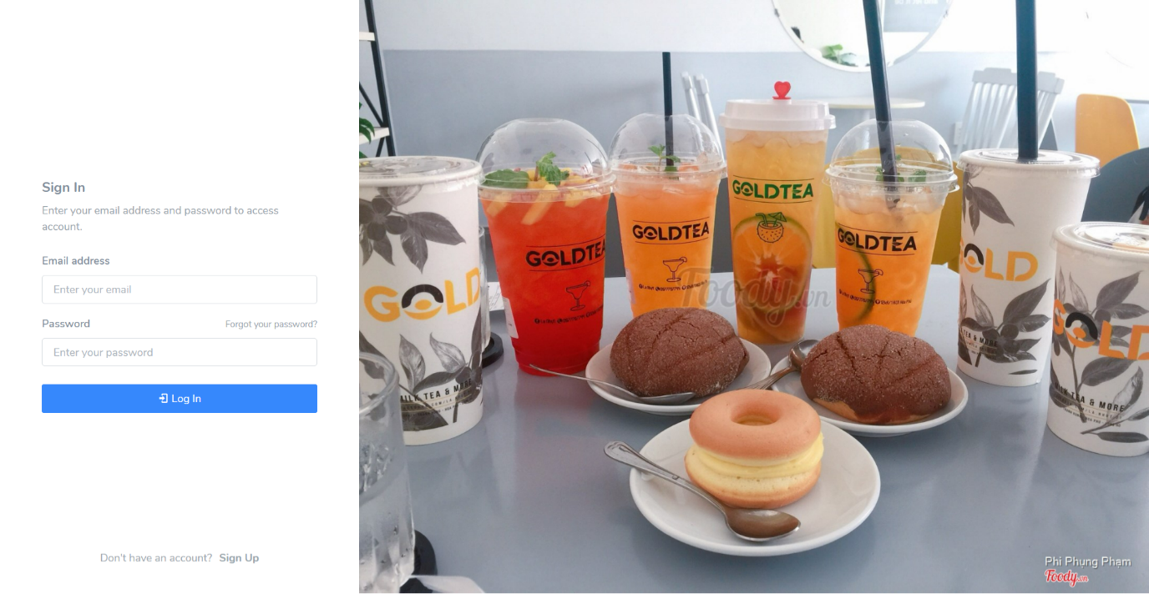

**3.4 Signup**

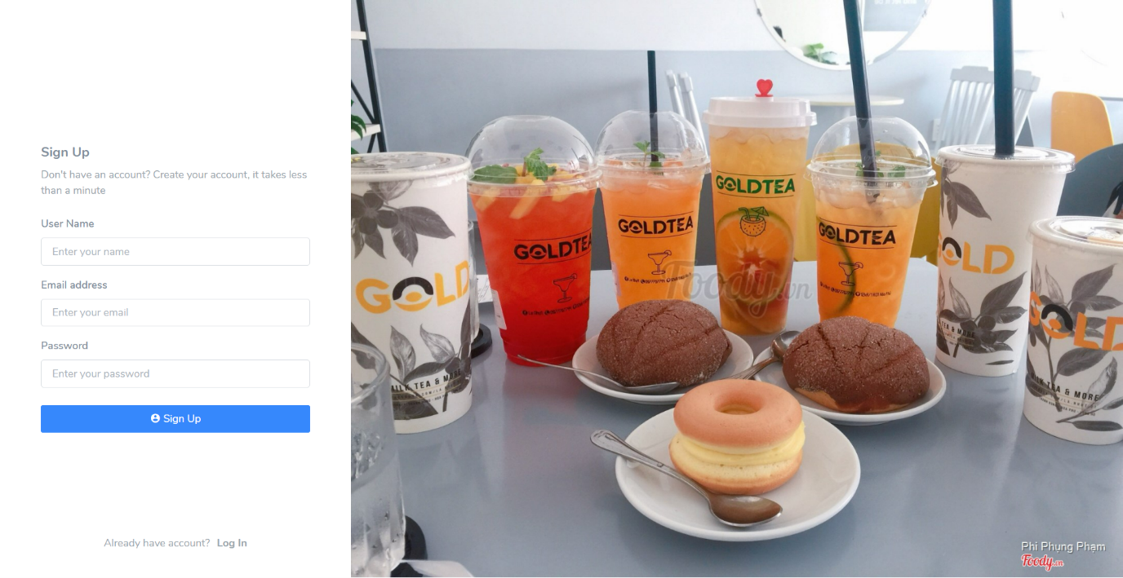

**3.5 Menu**

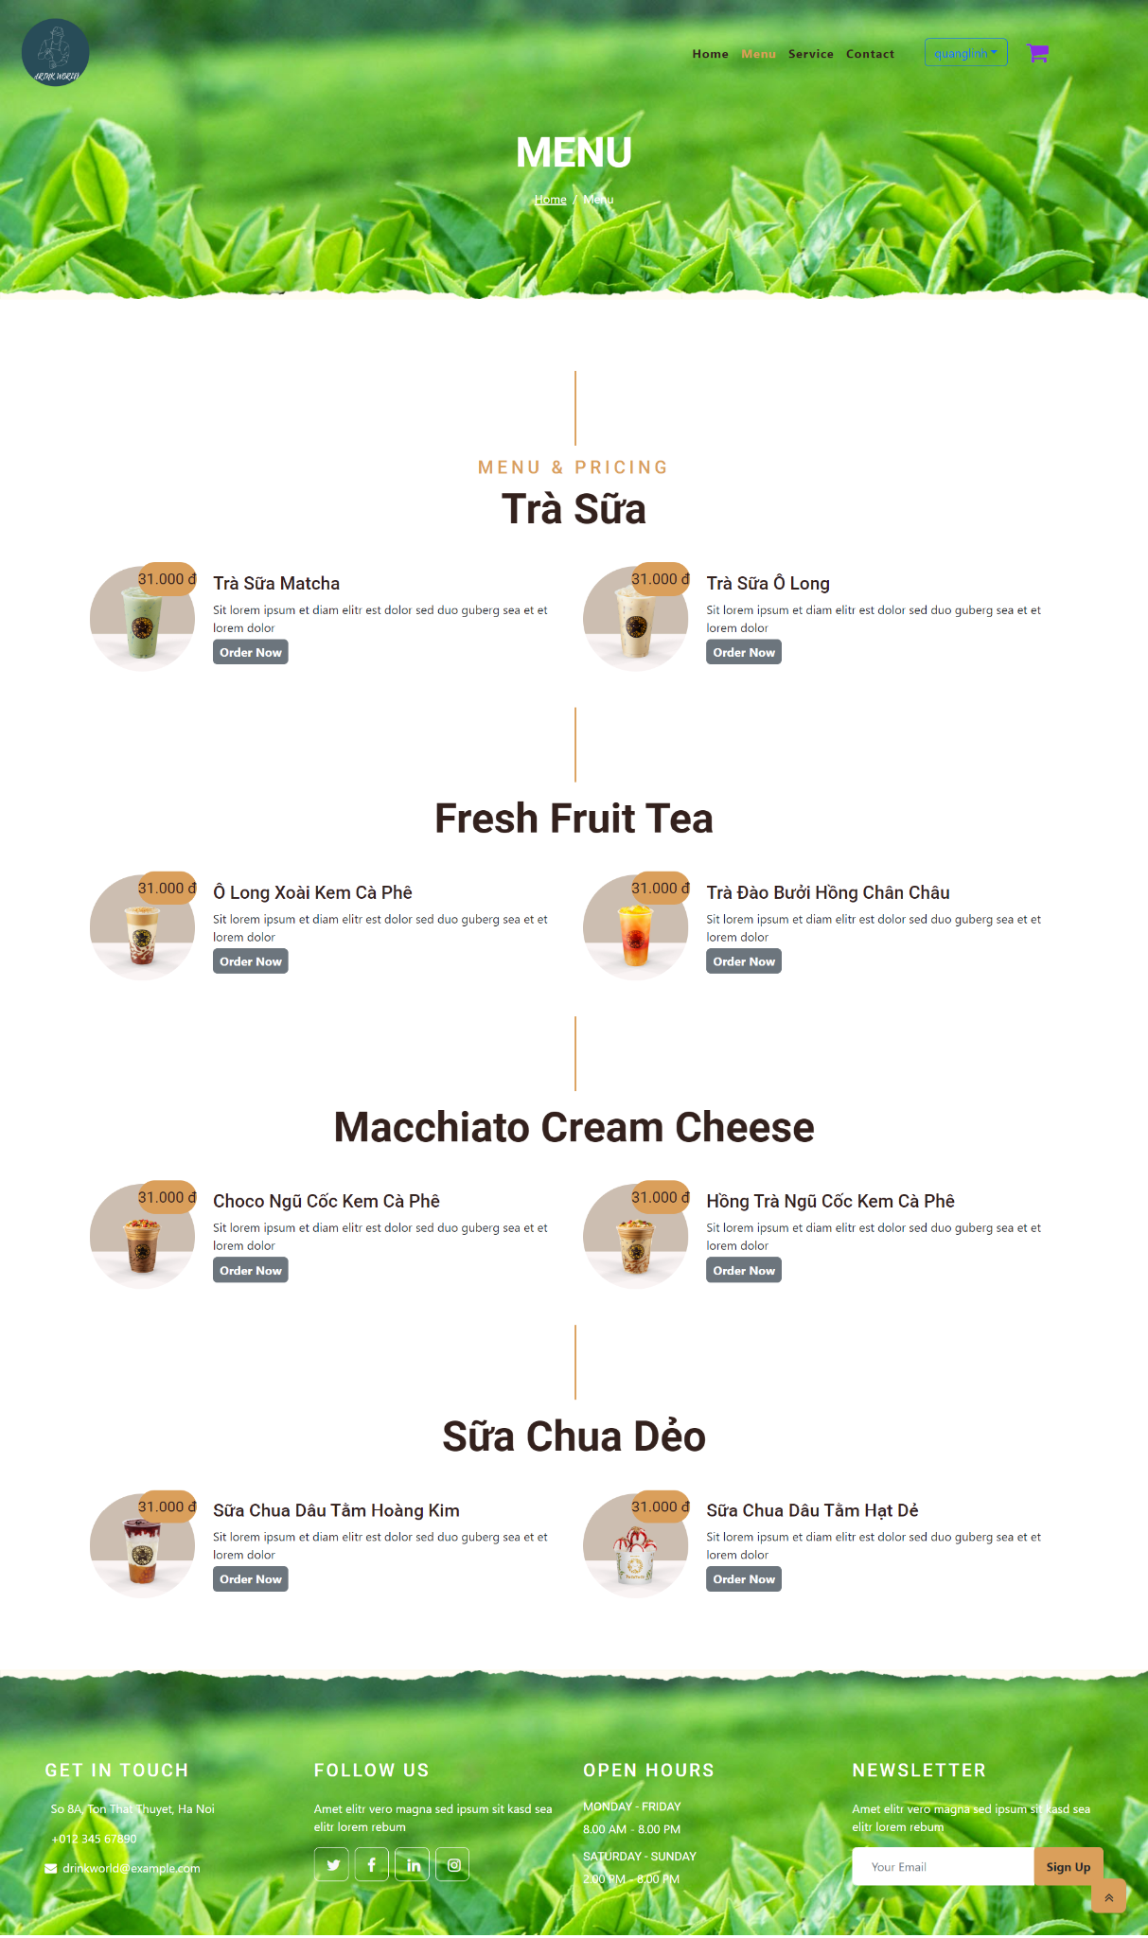

**3.6 Cart**

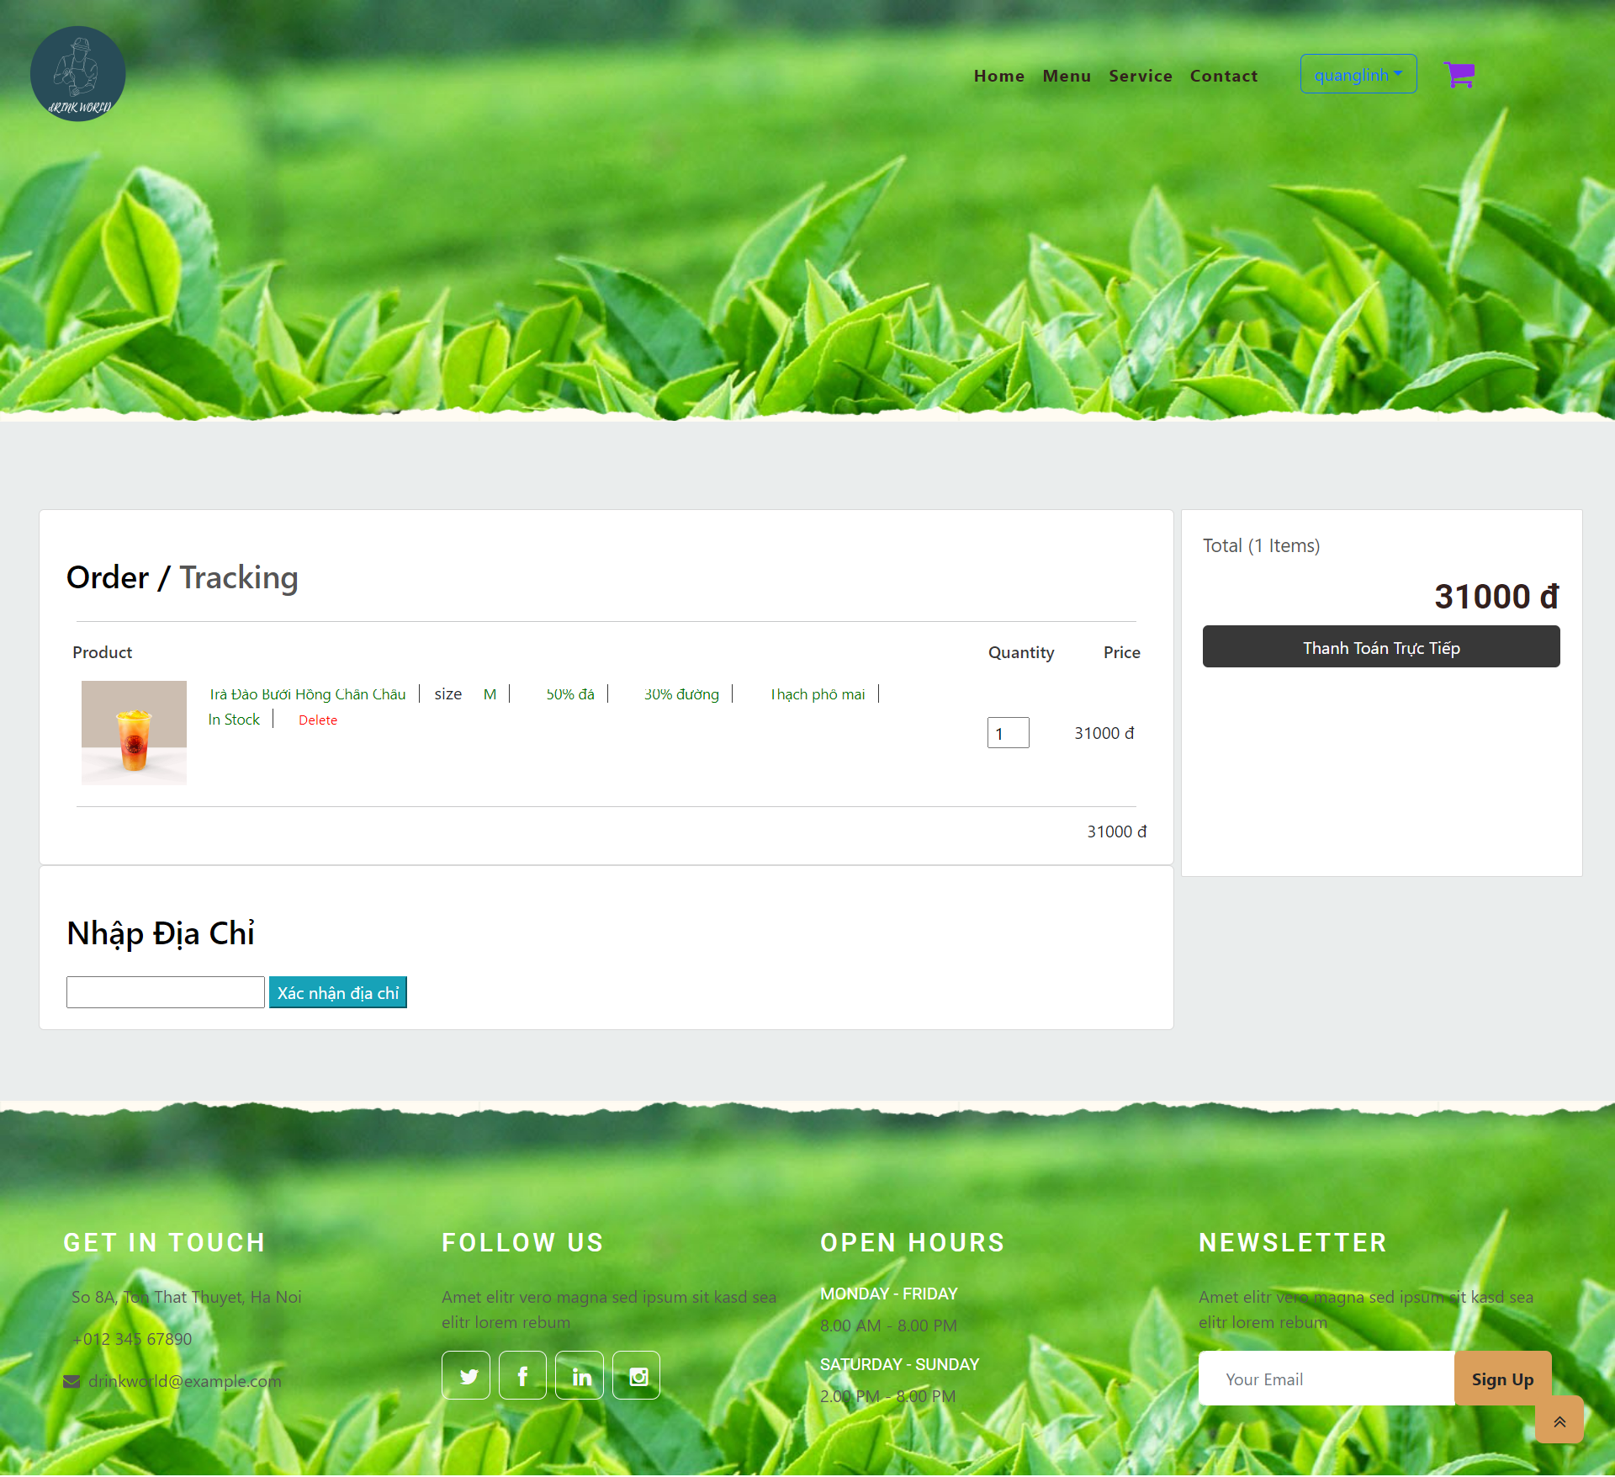

**3.7 Order**

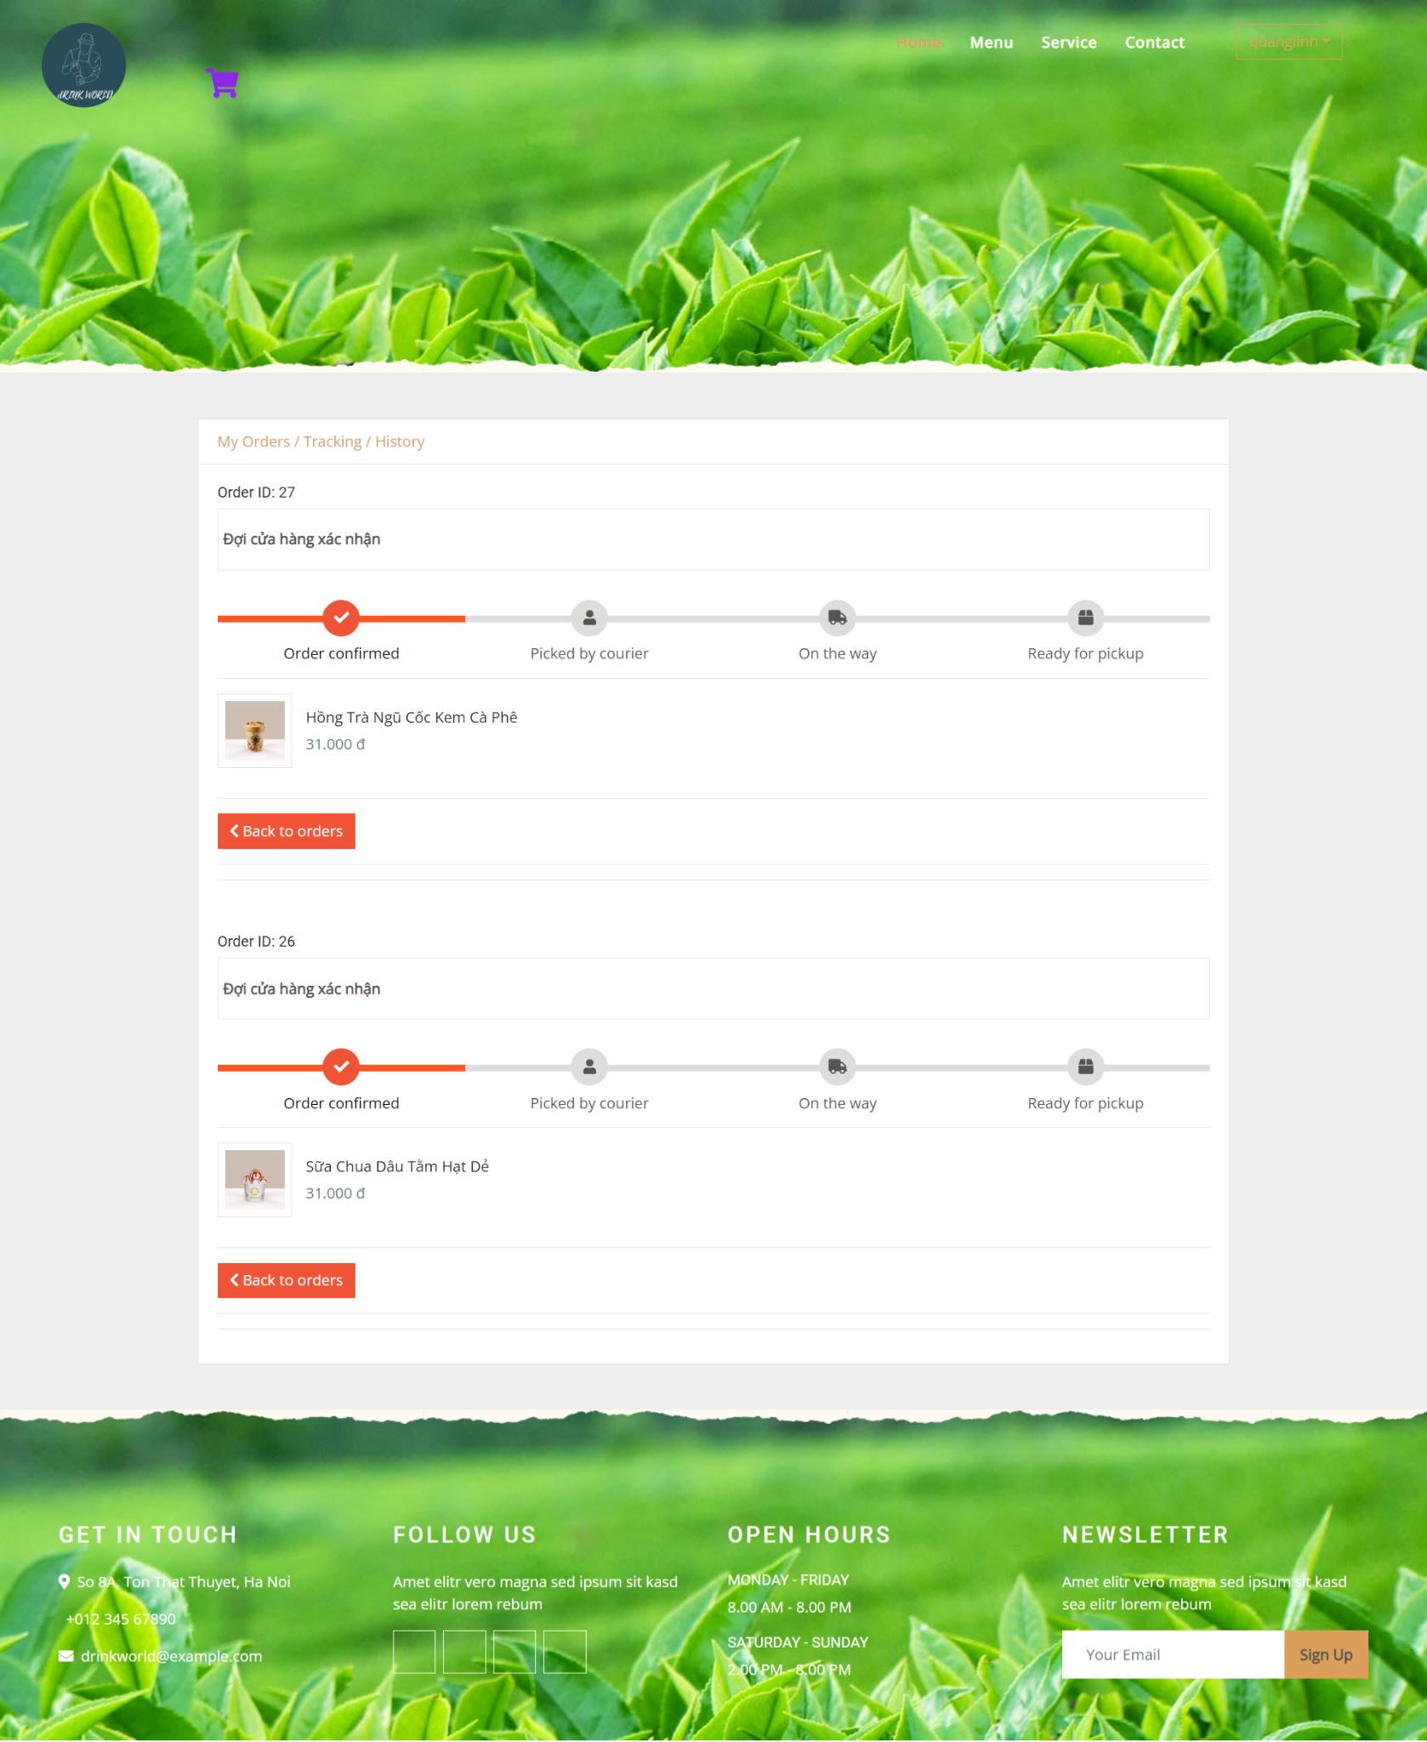

**3.8 History**

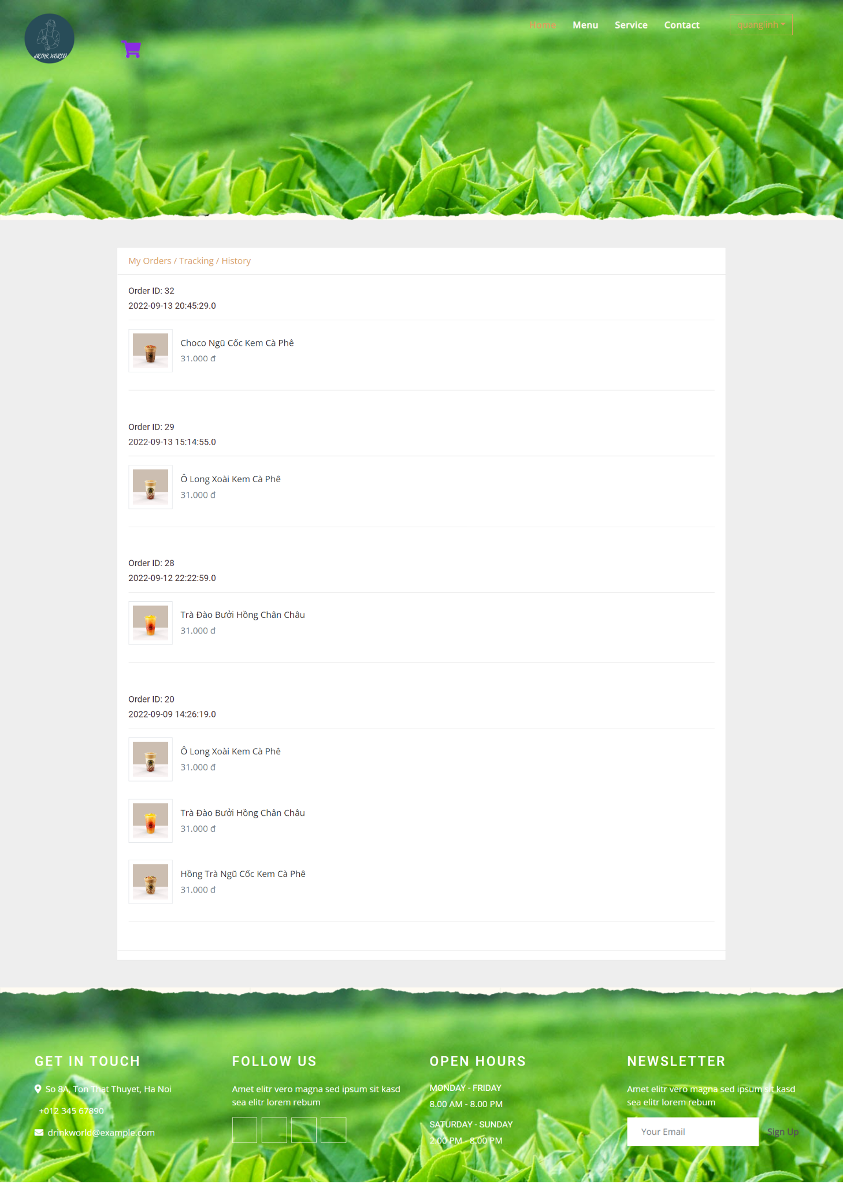

**3.9 Admin**

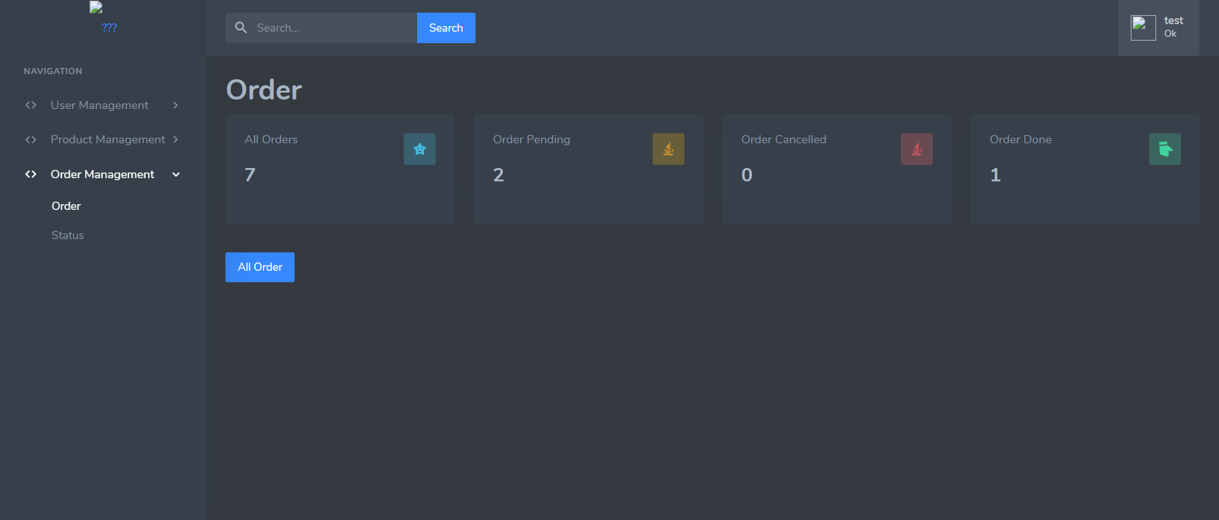

**3.10 Product detail**

4.

The (x) means that person took part in the individual work

For instance : Dao Quang Linh did the Homepage and Header ,...

|  |  |  |  |  |  |  |
| --- | --- | --- | --- | --- | --- | --- |
|  |  | Dao Quang Linh | Le Xuan Bac | Nguyen Du Quynh Nga | Doan Quang Manh | Le Anh Dung |
|  | Homepage |  | x | x |  |  |
|  | Header |  | x |  |  |  |
|  | Find resources: images and information of Wallet |  |  | x |  |  |
|  | Logo design |  |  |  |  | x |
|  | Login |  | x |  |  |  |
|  | Brands Details |  | x |  |  |  |
|  | All Brands |  | x | x |  |  |
|  | Categories | x |  |  |  |  |
|  | All Categories | x | x |  |  |  |
|  | Contact us | x | x |  | x |  |
|  | About us | x | x |  |  |  |
|  | Footer |  | x | x |  |  |
|  | Register |  | x |  |  |  |
|  | Search |  | x | x |  |  |
|  | Product Details |  | x | x |  |  |
|  | Merge Code |  | x |  |  |  |
|  | Feedback |  | x |  |  |  |
| 18. | Map page | x | x |  |  |  |
| 19. | 404 page |  | x |  |  |  |
| 20. | Cart | x | x | x | x |  |
| 21. | Checkout | x | x |  |  |  |
| 22. | Product Detail 2 |  |  | x |  |  |
| 23. | Product Detail 3 |  |  | x |  |  |
| 24. | Term | x | x |  |  |  |
| 25. | Policy |  | x |  |  |  |
| 26. | Add product |  | x | x | x |  |
| 27. | Api map |  |  | x |  |  |

**Thank you !**

**End.**